Team SQL-Poornima University

Project (Ratio of cost of job)

10-May-2020(Sunday)

All the members are working over the concepts and their learning part. The topics to be covered by EOD are:

* JOIN
* Subquery
* Inner query

Create a database for the given scenario.

* Data Structure of database

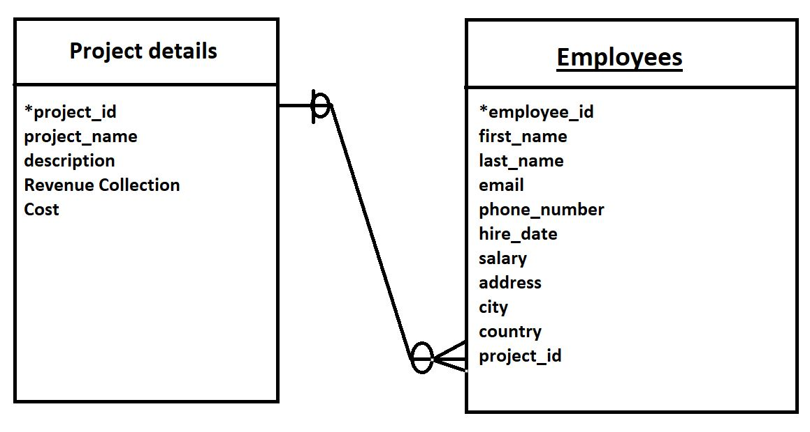

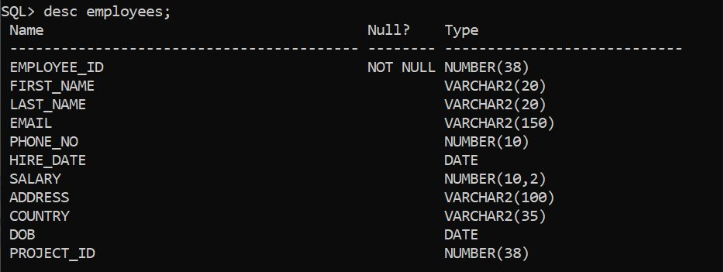  
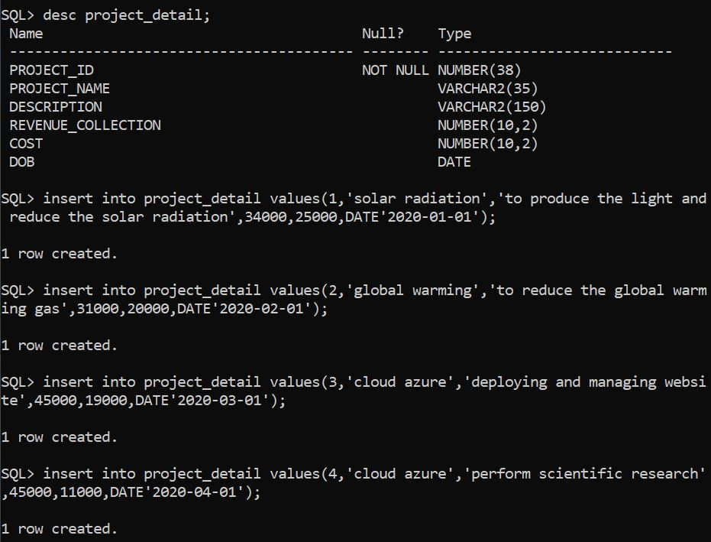

Each team member would be updating the progress in the drive by EOD.

Thank you